  - #SaveAlabamaParks

Grassroots Organization Toolkit
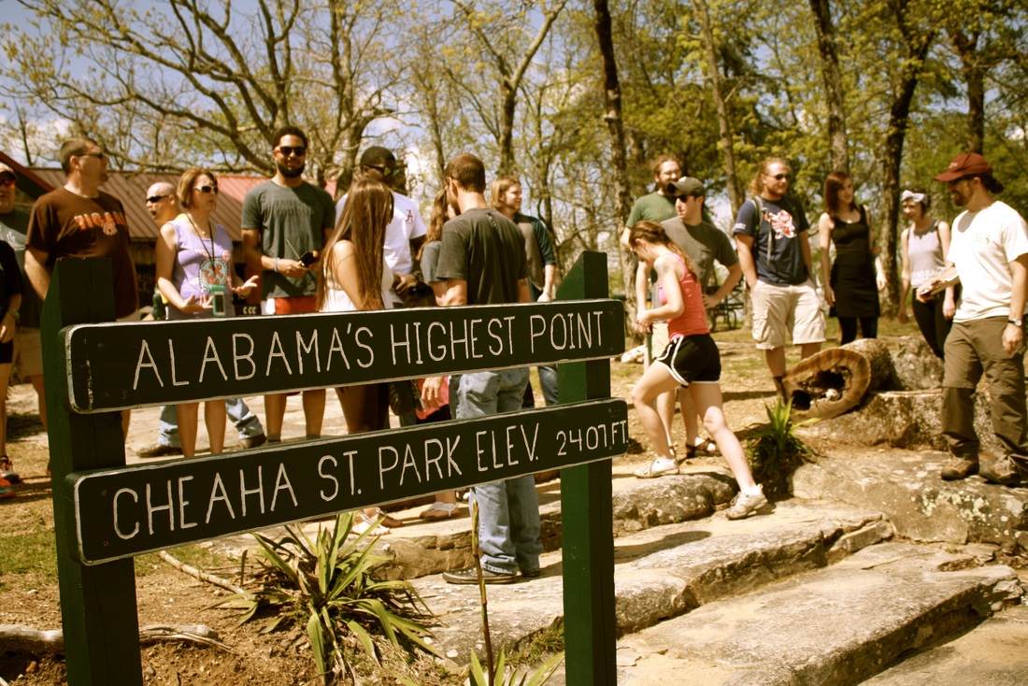
Alabama State Parks Partners, Save Our Parks
Web: http://savealabamaparks.weebly.com

Table of Contents
Opening Message 3
Who We Are 3
What is grassroots advocacy? 3
Important Keys for Success 4
Sample Docs 7
Meeting notes – Cheaha PSA 7
‘Next Steps’ Information 9
Sample Script – Cheaha PSA 10
Film Release 12

Opening Message
This toolkit was developed to help concerned community members in Alabama organize local efforts to save Alabama State Parks. It’s nothing fancy, just a collection of resources and lessons that we learned while making the Save Our Parks – Cheaha PSA. So, please feel free to make changes, try new things, and find what works for y’all! This is free information, and we invite you to use anything that you find useful. Please help us work to keep this issue in the media and on our minds. Thank you!

-Najeda (Jade) Patolo, #SaveAlabamaParks

Who We Are
We are students, educators, employees, business owners, retired individuals, and community members. We are Alabamians, and we love our state parks and public spaces. We started the #SaveAlabamaParks movement so that we can do something about potential park closures.
The first community film that we made for Cheaha State Park was a group effort that required organization to get the message out in a timely manner (seven days). We ended up getting almost 40 participants, forming media partnerships, and finding new ways to reach different community groups. If you, too, would like to create your own PSA but are new to organizing, we’ve developed a brief guide to help you get going!

What is Grassroots Advocacy?
Grassroots advocacy refers to raising awareness in your community (at the local level) about federal or state issues. The movement is inclusive and works from the ground (the grassroots) up. This type of action depends on everyone reaching out to neighbors, family members, church groups, and colleagues to educate them about the issue and increase support.

Important Keys for Success
We’re all here to stop Alabama State Legislature from diverting funds that would force our parks to close. This is the important thing to remember: we’re all here to Save Our State Parks.

- Develop Message and Stay On Message. It’s important to remember why we’re all here. It’s to Save Our State Parks. No other political or economic agenda need be discussed here. We all may have different opinions on other topics, but we’re not here to discuss those. Everything else is a distraction and could serve to disrupt the movement and cause us to lose credibility and numbers. Remember: We Are Here To Keep State Parks Open.
- Create a Plan of Attack
Everyone has something to contribute! Once you have a small group of people, begin working to spread your message to other groups in your community. It helps to create a quick document with bullet points of important information that can be distributed throughout your community.

Important: Make sure that contact local park officials and let them know what you are doing. They may direct you to send an email to Greg Lein’s office (email address and sample below). All Alabama State Park information can be found on the AlaPark website (see table below).

- Outreach
Once you have the basic information down, send everyone out into their community (church groups, youth groups, clubs, reading circles, businesses, etc.) to get as many people involved as possible. It helps to do this quickly before people lose interest. Schedule another larger meeting ASAP with everyone invited.

Task assignment
These are community movements, and so everyone is required to pitch in with outreach (telling more people about the event), education (giving info about our parks and resources to your community), and publicity. However, to make a single-day PSA, organizing people and tasks are most important. Basic things that are good to have are as follows:
- Media contact
- Script and/or general film plan (basic example for Cheaha PSA attached)
- Film/photographer (more are better!)
- Representatives from community groups
- Diversity of park users
* Some participants may have worked with/in film or photography, education and outreach, or operate in large community circles. Find out what everyone is interested in contributing and/or has experience with!

Deciding on a date for gathering
- Email lists or an FB event/group are a great way to reach your target audience and distribute directions/updates quickly.
- Use a free poll (http://doodle.com) so that everyone can select dates and times to meet.
- Make sure that information goes out regularly with quick, concise messages.
**IMPORTANT**
Accountability: These events only work if everyone is held accountable for the tasks that they signed up for. Meeting notes with task notes and assignments are helpful for helping everyone remember what he/she is responsible for completing.

Visibility
Get it out there! If you have contacts in television, newspaper, blogs, etc., make sure that they know what you are doing, why, and where.

Where to post:
-YouTube
-Facebook
-Personal websites
-Twitter
-Reddit

Here is a list of useful contacts and groups to help you get started!

Entity | Type | Email Contact | Where else can I find info?
Alabama State Parks Partners | Partner Group | alstateparkspartners@gmail.com | Facebook
Save Our State Parks | Facebook Group | N/A | Facebook only
WIAT News (Birmingham) | News Org | ReportIt@wiat.com | (205) 322-4665
Alapark.com | Information website | greg.lein@dcnr.alabama.gov | N/A

Together we can #SaveAlabamaParks. Thanks for staying wild!

Sample Docs

Meeting notes – Cheaha PSA

Logistics for Open Parks - 4/26/15 12:15 PM
Attendees: Allen Jones, Lindsey Hayes, Hayley Long, Tiffany Deboer, Jacob Bramlett, Rachel Brinks, Jade Patolo

Participants
- Total estimated participants: 20+
- Potential participants: Jacob +6, Lindsey and Allen +2, Tiffany +10-20, Rachel +1, Jade and Steve, Andrew and Payten, Xavier,
- Leaving from Jacksonville – Jade can drive (3)

Quick notes:

We are:
- Community interest group
- Volunteer centered
- Grassroots organization in support of our resources (parks)

We are not:
- A JSU group (we have students and faculty, but act independently)
- A political interest group
- Affiliated with any official organization

New tasks:
- Hayley Long: Contact Anniston Star
- Rachel Brinks: Contact local news station – can they send someone out?
- Allen Jones: Forward all information to Xavier Dekarske for Earth Club distribution.
- Jade Patolo: Contact Alabama Environmental Council and Wild South Cheaha Wilderness Rangers
- ALL: Contact any potential people with film equipment (GoPros, smartphones, etc.)

*FILM SCHEDULE*
Schedule: ALL - Meet at Cheaha State Park, Camp Store at 2:00 PM on Sunday 4/26. Park entrance fee for day use: $4.00
Potential weather date: TBA

1) Film crew: All participants’ names are needed. All participants being filmed must give permission on film (see script). Advise that this video will be posted to social media to support saving our state parks.

2) Main film crew: Tiffany, Allen, Andrew.
Andrew: general shots and give direction, Hayley and runners, rock climbers if necessary. Jade or Steve will assist if necessary to split up.
Tiffany: stick with large group, separate film events (jump). Jade or Steve will assist if necessary to split up.
Allen: Lindsay yoga and mountain bikers (Xavier).

3) All core group members: pictures. Finish up filming of people by 4:00 PM.

POST-FILMING:

Steps-
4/25/15-5/3/15
Editing: All footage will be sent to Andrew Green for editing and compiling.
2 minute video will go out ASAP (following week). 15-minute longer film to follow.

Distribution: Andrew, can you go ahead and upload to YouTube when it is finished? Need to figure out a channel. Jade and Francine will distribute to formal partners and channels (Save Our State Parks, Alabama Parks Partners, Cheaha State Park, Desoto, Wild South, Sierra Club, Gawker, etc.).

Pictures will be used in media and further outreach. They can be stored on Facebook or the Save Alabama parks website.

Funding: Rachel will look into a GoFundMe campaign to raise funds for outreach materials (posters, signage, fliers, etc.) for this and future campaigns.

‘Next Steps’ Information
Next steps
Keep informed!
Facebook
https://www.facebook.com/ALStateParksPartners
https://www.facebook.com/Save-Our-State-Parks

Websites
http://savealabamaparks.weebly.com
News
http://outdooralabama.com/news

Contact your local representatives
Legislative Action Center: http://capwiz.com/state-al/home/

Some local Representatives (Calhoun):
Brown
Hurst
Wood
Boyd
Lindsey
Some local Senate (Calhoun):
March
Dial

IMPORTANT CONTACTS:

Alabama State Parks Partners – a coalition of citizens, businesses and organizations dedicated to protecting our state parks: alstateparkspartners@gmail.com

Sample Script – Cheaha PSA
Script – Open Parks – Community PSA Cheaha State Park

All participants must sign the release to absolve the park in the event of an accident.

Participant: My name is [insert name here]. I give permission for any footage containing my image and voice to be used in this Open Parks - Cheaha Save Alabama Parks film project. I know that this film will be publicly distributed.

[On screen]

In April 2015, Alabama State Legislators unveiled plans to take more than $10 million from the State Parks Division of the Alabama Department of Natural Resources and Conservation. As a result of this action, Alabama State Park closings were set to begin May 1, 2015. Alabama State Parks are 80-90% self-funded. That means that they depend on park users to keep going. It’s a common misconception that taxes fund parks.

Alabama State Parks receive additional funding only from cigarette and use tax revenues (10%). This money supports annual maintenance and operation programs.
(Alabama State Parks 75th Report, 2015)

Spoken: Alabama the beautiful: fifth highest biodiversity in the country. We live in a beautiful, wild place with lands stretching from the Appalachian Mountains to the Gulf Coast. Twenty-two state parks, 15 are threatened with closure. When? We’re not sure maybe October of this year, maybe later. We’re the people who live here, work here, and play here. We are people who love our state and love our parks, and we are watching what is happening in Montgomery. We’ve come together today to Save Alabama State Parks and to remind our legislators about what’s important to Alabamians. We understand that there are budgetary matters to consider, and that changes may have to be made. But we do not accept losing our wilderness and more than 300 jobs for Alabamians, closing 15 of our 22 parks, and a $375 million loss in annual economic contributions to our state. So let us tell you in our own words what this means to us.

Spoken: We are the Save Alabama Parks movement - people from the community who love and value our parks.

We’ve all come together today in park that may be closed later on this year if things don’t change. Cheaha State Park. This park has been managed as a park continually since 1933; it is the last park left of the original 11 state parks, which extended from the Coosa Riverbank in Talladega County. Seventy-five years of history – one of the first parks established for Alabamians and visitors to enjoy could be gone this year.

[On screen]
Cheaha State Park is 2,800 acres of wilderness and trails situated next to the Talladega National Forest. It has the highest point in Alabama – 2,411 feet. It’s one of 3 wilderness areas for the state and contains the longest trail in the state, the Pinhoti. Threatened species of flora and fauna live in and around the park.

[SPACE FOR INTERVIEWS – people can tell their stories about the park, what they do there, why it’s important to them, etc.]

Interview questions:
- What’s your profession? Answer in “I am a________” format.
- How long have you been coming to Cheaha State Park?
- How often do you come here, and what do you enjoy doing in the park?
- How would you describe your connection to this place?
- What motivated you to join us here today?
- What would closing Cheaha and other parks mean to you?
- What will your reaction be if and when Alabama State Park closings begin?
- How closely have you been following what’s been happening regarding the de-funding of our State Parks? Will you continue to follow the news?
[On screen]

Together, we stopped closings from happening on May 1st. It takes everyone to protect our wilderness. Learn how you can help #SaveAlabamaParks:

Website: http://alapark.com/

Contact: ALStateParksPartners@gmail.com

On Facebook: Save Our State Parks, Alabama State Parks Partners

[Credits]
Thanks to all of our Open Parks Cheaha participants!
Special thanks (TBA – groups, etc.)

Film Release
*All participants agreed to sign a release in order to allow us to use their images on our website, Facebook pages, and the PSA.
Not required, but just something that gave everyone some peace of mind.

FILM RELEASE – OPEN PARKS (CHEAHA)

I, _______________________, give permission for any footage containing my image and voice to be used in this Open Parks - Cheaha Save Alabama Parks film project on April 26, 2015. I understand that footage containing my voice and image will be distributed publicly and via social media.

Signed:_______________________ Date:______________________

